 

Assignment -2

|  |  |
| --- | --- |
| **Student Name/ID Number:** | Agung Yuda Pratama / 0922-076 |
| **Academic Year:** | 2022 |
| **Unit Assessor:** | Archana Sakpal |
| **Project Title:** | Assignment 2– Spring MVC |
| **Issue Date:** |  |
| **Submission Date:** |  |
| **Internal Verifier Name:** | Archana Sakpal |
| **Date:** |  |

|  |
| --- |
| **Learner declaration** |
| I certify that the work submitted for this assignment is my own and research sources are fully acknowledged.    12/04/2023  Student signature: Date: |

You are developing a "Know-Your-Neighbourhood" application. The goal of this application is to provide details on all stores in the user’s neighbourhood. For this to happen, the application should have a list of stores in the town. Hence, develop Entity, Controller, Service and DAO classes to add store to the system.

1. Create the Store Entity object with below fields.

a. String name

b. String phone_number

c. String [] localities // list of areas or localities the store serves

Figure 1 – Model (Store.java)

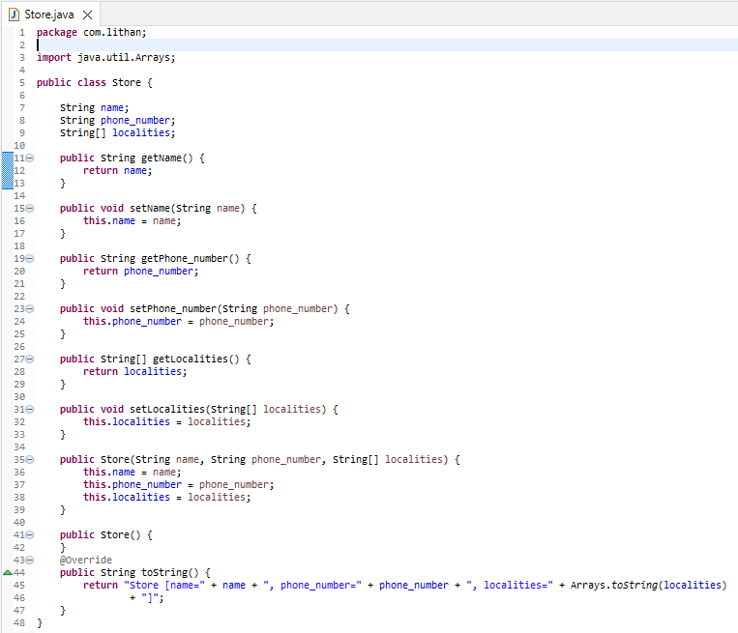

2. Develop a Controller class with a method to add Store to the system with POST HTTP method. http://:/stores

Figure 2 – Controller (StoreController.java)

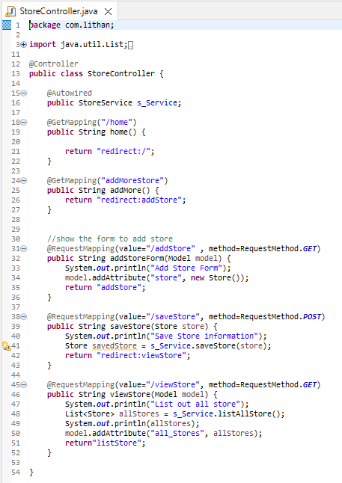

3. Develop a Service class to add Store to the repository

Figure 3 – Service (StoreService.java)

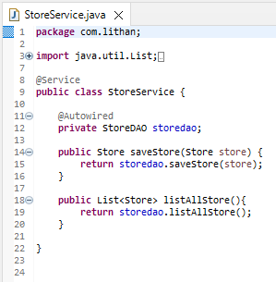

4. Develop a DAO class that just adds given store to the list of stores maintained.

a. We didn’t go through the database module yet.

b. So just maintain a list of stores as a field (i.e., member variable) in DAO class.

c. Add a store object to that list.

Figure 4 – Dao (StoreDAO.java)

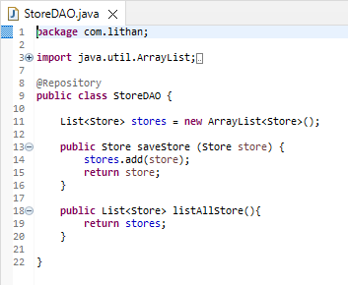

**---------------------------------Assignment 2 -- Spring MVC -- Result ----------------------------**

<Home>

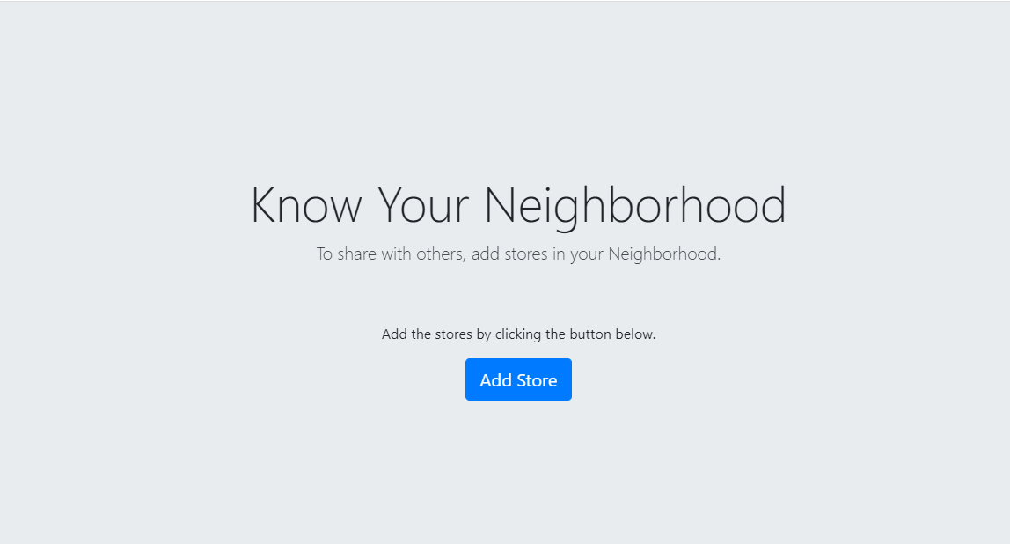

<Add Store>

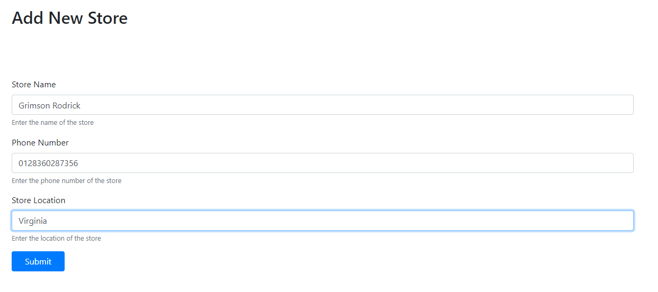

<List Store>

